**MongoDB -Aggregation Exercises**

Import the zip.json file into your MongoDB. Database name is “population” and collection name is “zipcodes”.

mongoimport --db population --collection zipcodes --file zip.json

**Atlanta Population**

1. use db.zipcodes.find() to filter results to only the results where city is ATLANTA and state is GA.

db.zipcodes.find({$and: [{city: "ATLANTA"}, {state: "GA"}]}).pretty()

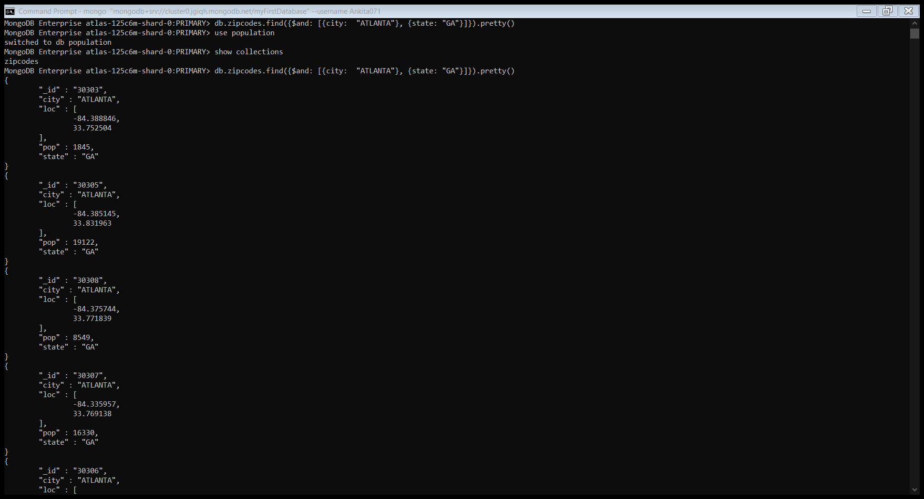

2. use db.zipcodes.aggregate with $match to do the same as above.

db.zipcodes.aggregate({$match: {$and: [{city:"ATLANTA"}, {state:"GA"}]}})

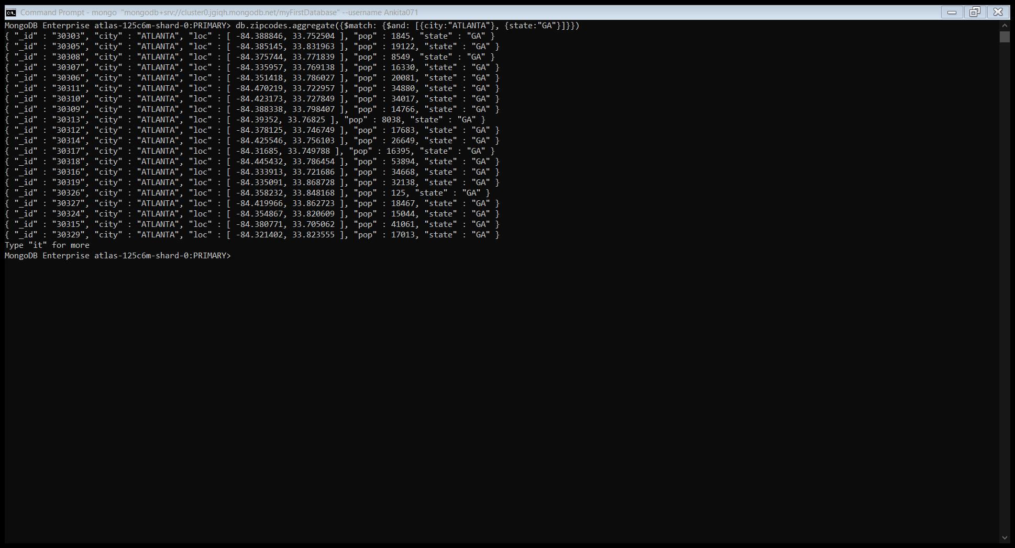

3. use $group to count the number of zip codes in Atlanta.

db.zipcodes.aggregate([{$match: {city: "ATLANTA"}}, {"$group" : {_id:"$city", count:{$sum:1}}}])



4. use $group to find the total population in Atlanta.

db.zipcodes.aggregate([{$match: {city: "ATLANTA"}}, {$group : {_id : "$city", totalPopulation : {$sum : "$pop"}}}])



**Populations By State**

1. use aggregate to calculate the total population for each state.

db.zipcodes.aggregate([{$group : {_id : "$state", totalPopulation : {$sum : "$pop"}}}])

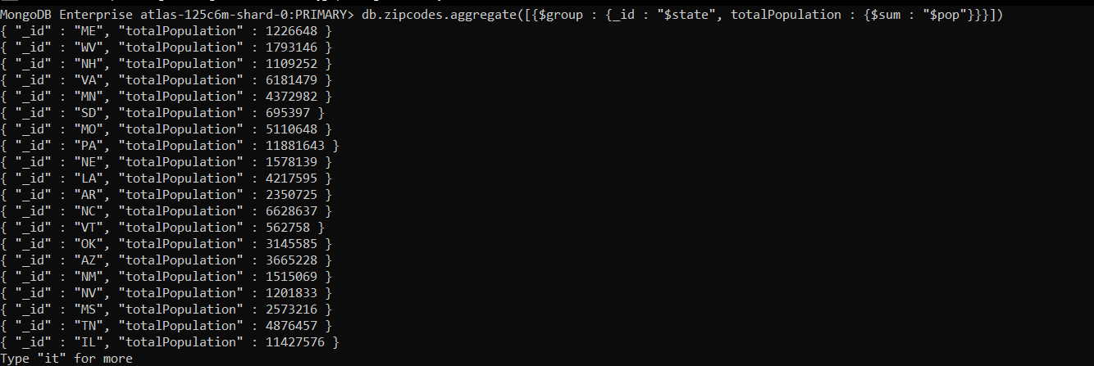

1. sort the results by population, highest first.

db.zipcodes.aggregate([{$group : {_id : "$state", totalPopulation : {$sum : "$pop"}}}, {$sort: {totalPopulation: -1}}])

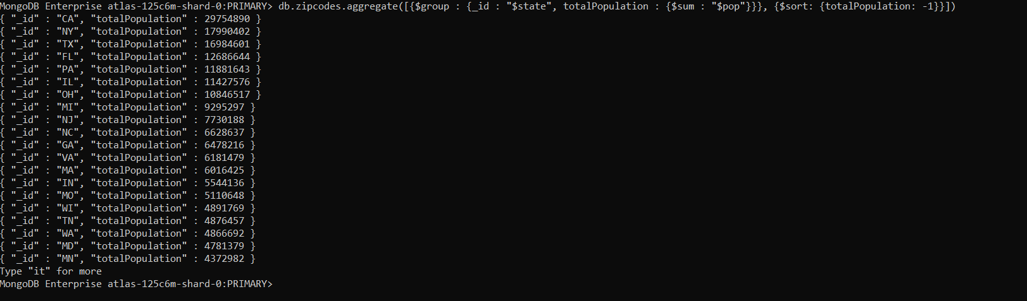

1. limit the results to just the first 3 results. What are the top 3 states in population?

db.zipcodes.aggregate([{$group : {_id : "$state", totalPopulation : {$sum : "$pop"}}}, {$sort: {totalPopulation: -1}}, {$limit: 3}])

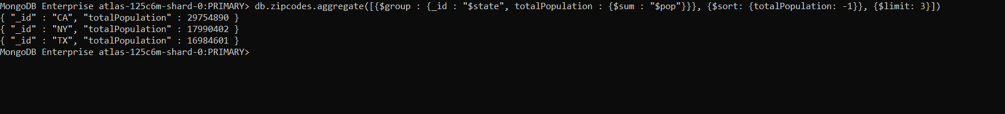

**Populations by City**

1. use aggregate to calculate the total population for each city (you have to use city/state combination). You can use a combination for the _id of the $group: {City: ‘$city’, state: ‘$state’ }

db.zipcodes.aggregate([{$group : {_id : {city: "$city", state: "$state"}, totalPopulation : {$sum : "$pop"}}}])

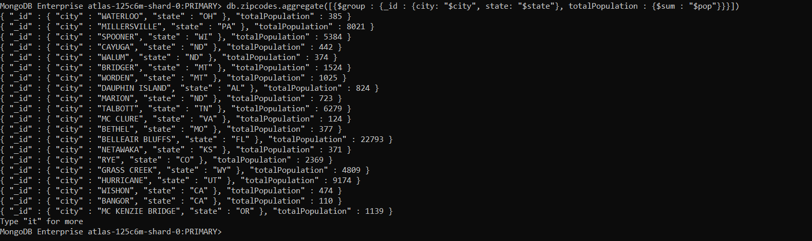

1. sort the results by population, highest first.

db.zipcodes.aggregate([{$group : {_id : {city: "$city", state: "$state"}, totalPopulation : {$sum : "$pop"}}}, {$sort: {totalPopulation: -1}}])

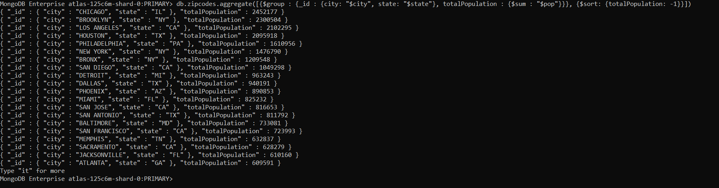

1. limit the results to just the first 3 results. What are the top 3 cities in population?

db.zipcodes.aggregate([{$group : {_id : {city: "$city", state: "$state"}, totalPopulation : {$sum : "$pop"}}}, {$sort: {totalPopulation: -1}}, {$limit: 3}])



1. What are the top 3 cities in population in Texas?

db.zipcodes.aggregate([{$match: {state: "TX"}}, {$group : {_id : {city: "$city", state: "$state"}, totalPopulation : {$sum : "$pop"}}}, {$sort: {totalPopulation: -1}}, {$limit: 3}])



**Bonus**

1. Write a query to get the average city population for each state.

db.zipcodes.aggregate([{$group : {_id : "$state", averageCityPopulationForState : {$avg : "$pop"}}}])

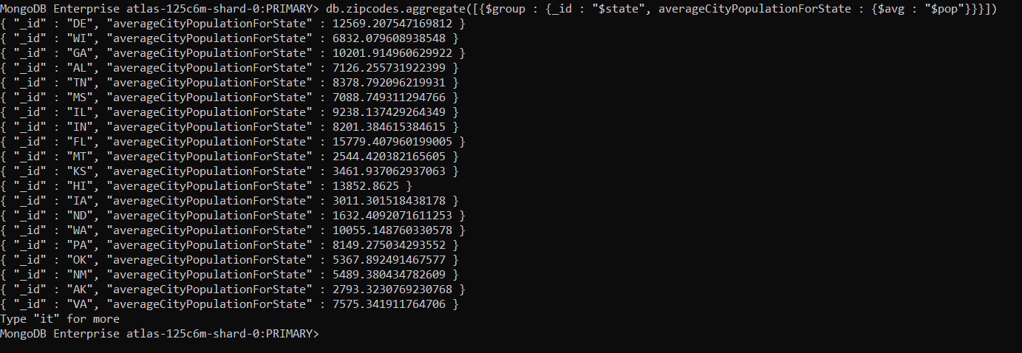

1. What are the top 3 states in terms of average city population?

db.zipcodes.aggregate([{$group : {_id : "$state", averageCityPopulationForState : {$avg : "$pop"}}}, {$sort: {averageCityPopulationForState: -1}}, {$limit: 3}])

